Flourishing through faith, hope and love
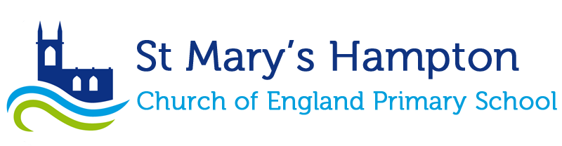
COOKIES Policy
Review Frequency: Annual
Next Review: Autumn 2024
Reported to: Resources Committee
Reviewed: Autumn 2023
Signed: 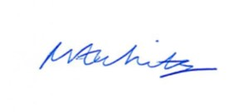
(Headteacher)

Cookies and Browser Settings
We use cookies on our website to simply to identify how visitors use our website. By using our website, you are agreeing for your web browser to receive all cookies from our website. No personal data is stored in any of the cookies used by our website

What is a cookie?
When you visit a site that uses cookies for the first time, a cookie is downloaded onto your device. A cookie is a simple text file. The next time you visit that site, your device checks to see if it has a cookie that is relevant (that is, one containing the site name) and sends the information contained in that cookie back to the site.
No personal data is stored in any of the cookies used by the school’s website.
This page covers St Mary’s Hampton School’s use of any personal information we collect from you via our website that links to the cookies policy.
This policy explains:
- What information we might collect about you
- How we use the information we collect about you
- How we use cookies and tracking on the St Mary’s Hampton website and how you can manage cookies yourself.

How we use cookies
When you visit www.stmaryshamptonschool.org.uk, we use cookies to store a little bit of information about you while you are using the website or, in some instances, to make your next visit even easier for you.
We collect anonymous information about how visitors use our website. For example, what pages they read, if our forms are easy-to-complete and what time of day they like to come and see us.
Similar technologies are also often used within emails to understand whether the email has been read or if any links have been clicked.

Strictly necessary cookies
‘Strictly necessary’ cookies let you move around the website and use essential features such as accessing our document store for parents. These cookies do not gather any information about you that could be used for marketing or remembering where you have been on the internet.

Measuring site usage
We use Google Analytics to build up information about how visitors use our website. Google Analytics store information about how visitors arrive, what pages are visited, for how long, and what visitors click on. This information allows us to understand how our visitors use the site and help us improve your experience. All information these cookies collect is aggregated and therefore anonymous. On occasion, we may share this information with analytics and search engine providers that assist us in the improvement and optimisation of our site.

Third-party cookies
If you share St Mary’s Hampton School pages on Facebook or other social websites, you may also be sent cookies from those websites. We do not control the setting of these cookies, so please check these websites' cookies and privacy policies (and any others that you might use) for information about what they do. For example:
- Facebook Privacy Policy
- Twitter Privacy Policy

Opting out
By using/browsing our website, you are approving the use of cookies as set out above and in line with our cookie policy. If you have an objection to our use of cookies, you can disable the cookies in your browser. If you disable cookies, then some parts of this website will not work, for example you will not be able to download a policy online as the web application requires cookies to function.

Opting out of Google Analytics
https://tools.google.com/dlpage/gaoptout
We will take all reasonable steps in accordance with our legal obligations to update or correct personally identifiable information in our possession that you submit on our site.

